**CTS DIGITAL NURTURE - 4.0 JAVA FSE**

**WEEK 2 -TDD using JUnit5 and Mockito**

**3. Mockito exercises**

**Adding dependencies:**

<!-- JUnit 5 -->

<dependency>

<groupId>org.junit.jupiter</groupId>

<artifactId>junit-jupiter</artifactId>

<version>5.9.3</version>

<scope>test</scope>

</dependency>

<!-- Mockito -->

<dependency>

<groupId>org.mockito</groupId>

<artifactId>mockito-core</artifactId>

<version>5.11.0</version>

<scope>test</scope>

</dependency>

MANDATORY HANDS-ON 4:

**Exercise 1: Mocking and Stubbing**

**Scenario: You need to test a service that depends on an external API. Use Mockito to mock the external API and stub its methods. Steps: 1. Create a mock object for the external API. 2. Stub the methods to return predefined values. 3. Write a test case that uses the mock object.**

PROGRAM:

**ExternalApi.java**

package com.example.junitdemo;

public interface ExternalApi {

String getData();

}

**MyService.java**

package com.example.junitdemo;

public class MyService {

private ExternalApi api;

public MyService(ExternalApi api) {

this.api = api;

}

public String fetchData() {

return api.getData();

}

}

**MySeriveTest.java**

package com.example.junitdemo;

import static org.mockito.Mockito.*;

import org.junit.jupiter.api.Test;

import static org.junit.jupiter.api.Assertions.*;

public class MyServiceTest {

*@Test*

public void testExternalApi() {

ExternalApi mockApi = *mock*(ExternalApi.class);

*when*(mockApi.getData()).thenReturn("Mock Data");

MyService service = new MyService(mockApi);

String result = service.fetchData();

*assertEquals*("Mock Data", result);

}

}

OUTPUT:

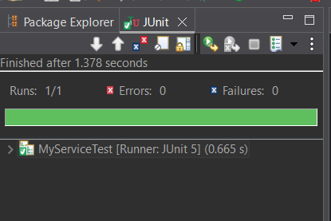

MANDATORY HANDS-ON 5:

**Exercise 2: Verifying Interactions**

**Scenario: You need to ensure that a method is called with specific arguments. Steps: 1. Create a mock object. 2. Call the method with specific arguments. 3. Verify the interaction.**

PROGRAM:

**ExternalApi.java**

package com.example.junitdemo;

public interface ExternalApi {

String getData();

}

**MyService.java**

package com.example.junitdemo;

public class MyService {

private ExternalApi api;

public MyService(ExternalApi api) {

this.api = api;

}

public String fetchData() {

return api.getData();

}

}

**MyServiceTest1.java**

package com.example.junitdemo;

import org.junit.jupiter.api.Test;

import static org.mockito.Mockito.*;

public class MyServiceTest1 {

*@Test*

public void testVerifyInteraction() {

ExternalApi mockApi = *mock*(ExternalApi.class);

MyService service = new MyService(mockApi);

service.fetchData();

*verify*(mockApi).getData();

}

}

OUTPUT:

